



Technical Design documentation

Document History

|  |  |  |  |
| --- | --- | --- | --- |
| Version | Updated By | Date | Comments |
|  |  |  |  |
|  |  |  |  |
|  |  |  |  |

Document Sign-Off

|  |  |  |
| --- | --- | --- |
| Name | Role | Signature/Date |
|  |  |  |
|  |  |  |
|  |  |  |

Table of Contents

1. Introduction 3

1.1 Document Purpose 3

1.2 Intended Audience 3

1.3 Document Scope 3

1.4 Hybris OMS Introduction 3

1.4.1 Hybris OMS Overview 3

1.4.2 Key Features 4

1.4.3 KEY BENEFITS 5

1.4.4 OMS default Cockpits 6

1.4.5 Hybris OMS Environment structure 7

2. Installation and Configuration 8

2.1 Setup 8

2.2 Initialize 8

2.3 Start 8

2.4 Test the OMS Installation 8

1. Introduction

This is a general overview of Order Management Services built on top of the hybris Core platform and its features. Learn how to install and configure Order Management Services. This provides a detailed description and instruction on how to use the Order Management Cockpit and the Order Fulfillment Cockpit

Document Purpose

This document provides installation and configuration details for Order Management Services within the hybris platform

Intended Audience

IT/hybris administrators, consultants, hybris Developers, hybris Testers & Solution Architects

Document Scope

The document applies on hybris Commerce Suite version 5.4.0.5 where OMS is based on the core+ architecture.

Hybris OMS Introduction

### Hybris OMS Overview

hybris Order Management Services (OMS) allows you to view and manage customer orders, print out pick slips, pack slips and shipping labels, review and edit package and shipping information, search for and view your inventory information by SKU or by location, search for and manage stockroom locations, and view information imported into OMS from the hybris Accelerator.

The hybris Order Management Services (OMS) is a fully integrated order management and fulfillment tool that is designed to optimize the customer experience and make omni-channel fulfillment options—like buy online and pick up in store and cross-channel stock-level display— a reality. Business users can use the OMS to get an overview of inventory across your different stock locations—in your stores, warehouses and distribution centers and have an instant overview of orders that need to be fulfilled. They can easily prepare orders for shipment or for in-store pickup.

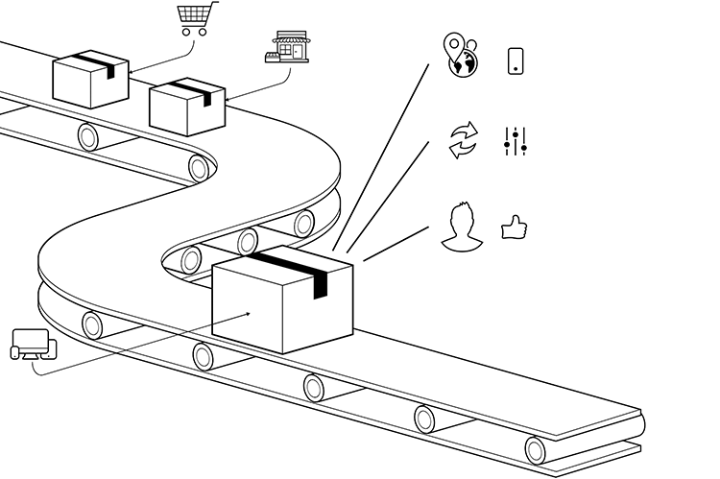

### Key Features

* Real-time inventory management across all stock locations
* Automated order workflow
* Advanced sourcing strategies
* Order splitting rules.
* Ability to pick, pack, label, and confirm shipments through the OMS Cockpit
* Accelerator and Commerce Infrastructure Services integration

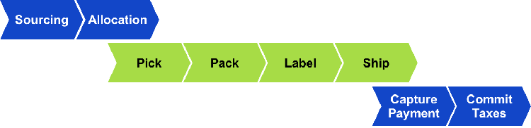

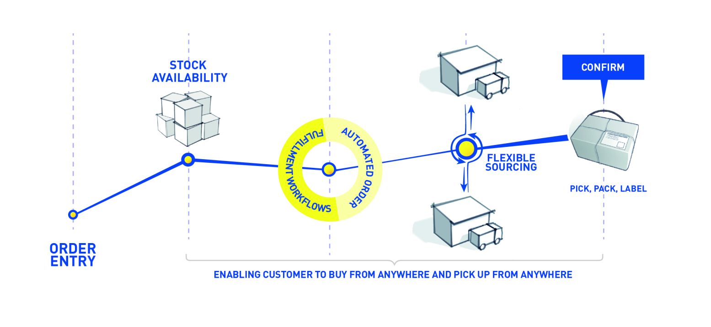

**Figure: The hybris OMS Key Features**

* Sourcing

Sourcing is the action of determining which physical location (or locations) will supply all items for an order.

* Allocation

Allocation is the action of grouping order items into shipments (that is, determining which items of an order will be shipped from a single location in a single box or package).

* Pick, Pack, Label, and Ship

Once an order is allocated, the following steps in the order workflow take place:

* A pick list is printed, which lists the item(s) that need to be collected from the store or warehouse shelf.
* A pack slip is printed, which indicates all the items that need to be packed in a single shipping box or package.
* A label is printed, which displays the customer's shipping address. Details vary depending on the shipping carrier.
* The order is shipped and confirmation of the shipment is logged in the OMS.
* Payment Capture

After the order is packed and ready to be shipped, the payment is charged to the customer. OMS communicates with a third-party payment service provider (for example, CyberSource) to complete the payment capture.

* Commit Taxes

The final step of the workflow is to determine the tax amount of an order and to log the information, so that a tax invoice can be created. OMS communicates with a third-party tax invoicing service (for example, Avalara) to complete the tax invoicing.

### KEY BENEFITS

Enable customers to buy from anywhere and pick up from anywhere

* Enable Buy Online Pick Up In Store
* Reduce online cart abandonment by sourcing out-of-stock products from store inventory
* Reduce shipping times for online orders through ship-from-store initiatives

Improve efficiencies and reduce costs

* Reduce overhead stock levels and optimize prices and selection
* Improve delivery efficiencies and reduce shipping costs
* Reduce store markdowns by routing online orders to stores with slow item turnover or excessive inventory risk
* Fulfill from anywhere
* Save the sale by preventing inventory stock-outs
* A centralized view of inventory
* Create availability formulas according to your own business rules
* Reduce shipping time and shipping costs
* The ability to orchestrate a true Omni Commerce journey through click & collect
* Improve the in-store customer experience

### OMS default Cockpits

Provide business users with an easy-to-use UI to efficiently manage fulfilment processes

* + OMS Cockpit (for Warehouse and Shop Staff)

The hybris OMS Cockpit allows you to:  
 - View and manage customer orders, such as print pick slips, pack slips, and shipping labels, as well as review and edit package and shipping information.  
 - Search for and view your inventory information. You can search based on the inventory's SKU or by location.  
 - Search for and manage stockroom locations.  
 - View information imported in to the OMS from the hybris Accelerator or from files you uploaded.

* + Returns and Refunds Cockpit (for Warehouse and Shop Staff)

The hybris Returns and Refunds Cockpit allows you to:

- Create returns.  
 - Search for orders for which customers want to return items. You can search by order ID or SKU.  
 - Search for returns by return ID or order ID.  
 - Confirm automatic and manual returns.  
 - Manually modify the amount to be refunded on returned orders.

* + OMS Admin Cockpit (for an Administrator for Application Management)

The hybris OMS Admin Cockpit allows you to:  
 - Create, modify, or delete ATS formulas  
 - Create, modify, or deactivate order line quantity statuses  
 - Create, modify, or delete sourcing strategies for orders, order lines, and order line quantities  
 - Configure preferences for a tenant such as ATS calculator, item grouping, order and order line splitting, and OLQ statuses  
 - Configure inventory management rules

### Hybris OMS Environment structure

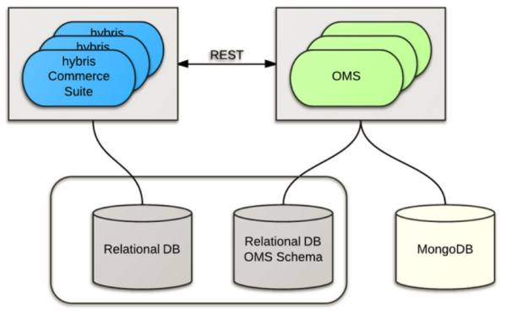

* Application server which runs the hybris Commerce Suite
* Relational database server for hybris Commerce Suite and/or OMS.
* Application server (or cluster) which runs the OMS.
* The MongoDB engine was selected because of its aggregation capabilities, and its handling of big data suits the OMS project requirements.
* When an order is received from the hybris Accelerator, OMS processes and completes the order by performing the steps as shown in the following figure

1. Installation and Configuration

## Setup

To setup the hybris platform with the OMS extensions, run the following command:

**Windows: install.bat -r b2c_acc_oms setup**

**Unix: ./install.sh -r b2c_acc_oms setup**

## Initialize

To initialize the platform, run the following command:

**Windows: install.bat -r b2c_acc_oms initialize**

**Unix: ./install.sh -r b2c_acc_oms initialize**

## Start

To start the platform, run the following command:

**Windows: install.bat -r b2c_acc_oms start**

**Unix: ./install.sh -r b2c_acc_oms start**

## Test the OMS Installation

Go to <https://asianpaints.local:9002/asianpaintsstorefront/> place an order for an item e.g. Luxury Wood. Follow instruction to continue your checkout.

To test if OMS has received the order you placed, just point your browser to: <http://localhost:9001/backoffice/>, then click on the Order Fulfillment icon at the top of the window. Then go to "Order Shipping" and click on "All Consignments".

